SMPL: Component Goods Issue
Test Script

Template Version Number: 1.0

Document Approval / Review (To be completed pre-execution of Tests)
 | Name & Role | Signature | Date
Author
Reviewed
Approved
Approved | Add more rows as needed

Version Control
Version | Date | Description of Changes | Author
 |  | Add more rows as needed

Referenced Documents
No. | Document Title and ID | Version | Location
 | Add more rows as needed

Disclaimer
If you are reading a copy of this document (i.e. print out of controlled electronic document or an electronic copy of a wet ink signed paper document) you may be reading an uncontrolled version. Before making updates, please ensure that you are using the latest version of this document and the associated template.

Test Script ID & Version #: | Test script ID must be unique | Test Phase: | ARS Unit Test
Test Name: | SMPL: Component Goods Issue
Test Objective: | To verify that the SMPL: Component Goods Issue XStep correctly records and communicates component consumption data from execution to SAP, ensuring accurate goods issue posting, material traceability, and compliance with process order and EBR requirements.
Requirements Tested: | The test confirms that valid process orders with assigned XSteps enable accurate entry and validation of material, batch, quantity, and storage data, trigger correct Z_PICONS message posting for goods issue, and enforce electronic signature control for traceable completion.

Pre-requisites:
- Valid Process Order: A process order must exist in SAP with the SMPL: Component Goods Issue XStep correctly assigned.
- XStep Assignment: The XStep must be correctly assigned to the process order via the relevant master recipe.
- System Configuration: The process message Z_PICONS communicates goods issue data from XStep execution to the backend system, posting component consumption (e.g., movement type 261) with relevant material details and ensuring accurate process order updates and traceability.
- User Access: The test user must have sufficient SAP authorizations to execute SiMPL EBR, view the process order in COR3, and return to the EBR.
Set Up Steps: | Data Requirements:
Input Parameter Setup: In SiMPL MBR, the following input parameters should be populated with test values to validate display functionality:  - IV_HEADER: Left as DEFAULT  - IV_INSTR: Left as DEFAULT  - IV_TABTITLE: Unplanned Goods Issue  - IV_STG_LOC – This can be changed to indicate the Storage Location for material consumption. The parameter is by default set to “0010” for AZGPF.  - IV_SIGN: Left as DEFAULT | Provide details of any specific data required to execute this script e.g. name and location of a data file to be loaded

System Name & Version #: | G20 | All pre-requisites satisfied/set up steps completed? |  | Yes
Environment: | ARS
Tester Name: | Frieda van der Merwe (kvhz810) | Date Test Commenced: | 19/02/2026 | Run # | 1

Instructions for the Tester:
- Carry out the action described in each step and compare the results achieved with the Expected Result to determine if the step has passed. Record the Pass / Fail status against each step.
- If the Expected Result is not met or an issue is encountered, record the related Test Issue Log (TIL) number in the Pass/Fail column against the relevant step.
- For GxP regulated systems you must document the Actual Result for the step .
- For GxP systems, wherever specifically required by the test script, documentary evidence must be collected and appropriately managed. At your own discretion you may collect additional documentary evidence to support the results achieved.

Variant 1: Component Goods Issue

Step No. | Action / Description | Expected Result | Actual Result | Pass/ Fail  Test Issue Log #
1 | Create a Process Order that contains a SMPL: Component Goods Issue | Process Order created containing SMPL: Component Goods Issue | Process Order created containing SMPL: Component Goods Issue | Pass
2 | Open the EBR, and navigate to SMPL: Component Goods Issue | The EBR for the selected Process Order and Control Recipe opens successfully without any errors and the SMPL: Component Goods Issue is visible | The EBR for the selected Process Order and Control Recipe opens successfully without any errors and the SMPL: Component Goods Issue is visible | Pass
3 | The value entered in parameter IV_HEADER and parameter IV_INSTR in SiMPL MBR appears correctly in the XStep header | Header and instruction text are displayed as authored in SiMPL MBR | Header and instruction text are displayed correctly. | Pass
4 | Operator inputs Material, Batch, Serial Number, Qty, Scrap Qty., UoM. | Input details are accepted and correct. | Input details are accepted and correct. | Pass
5 | The operator verifies that Description and Exp. Date details are populated correctly. | Output details are populated correctly. | Output details are populated correctly. | Pass
6 | Enter a username in the “Performed By” field then enter the password in the pop-up window. | Signature is accepted | Signature is accepted | Pass
7 | Navigate to transaction CO54 to ensure process message is created successfully for goods issued on the current order (see last screenshot) | Process message exists with the correct details. | Process message exists with the correct details. | Pass

Step 1-3:
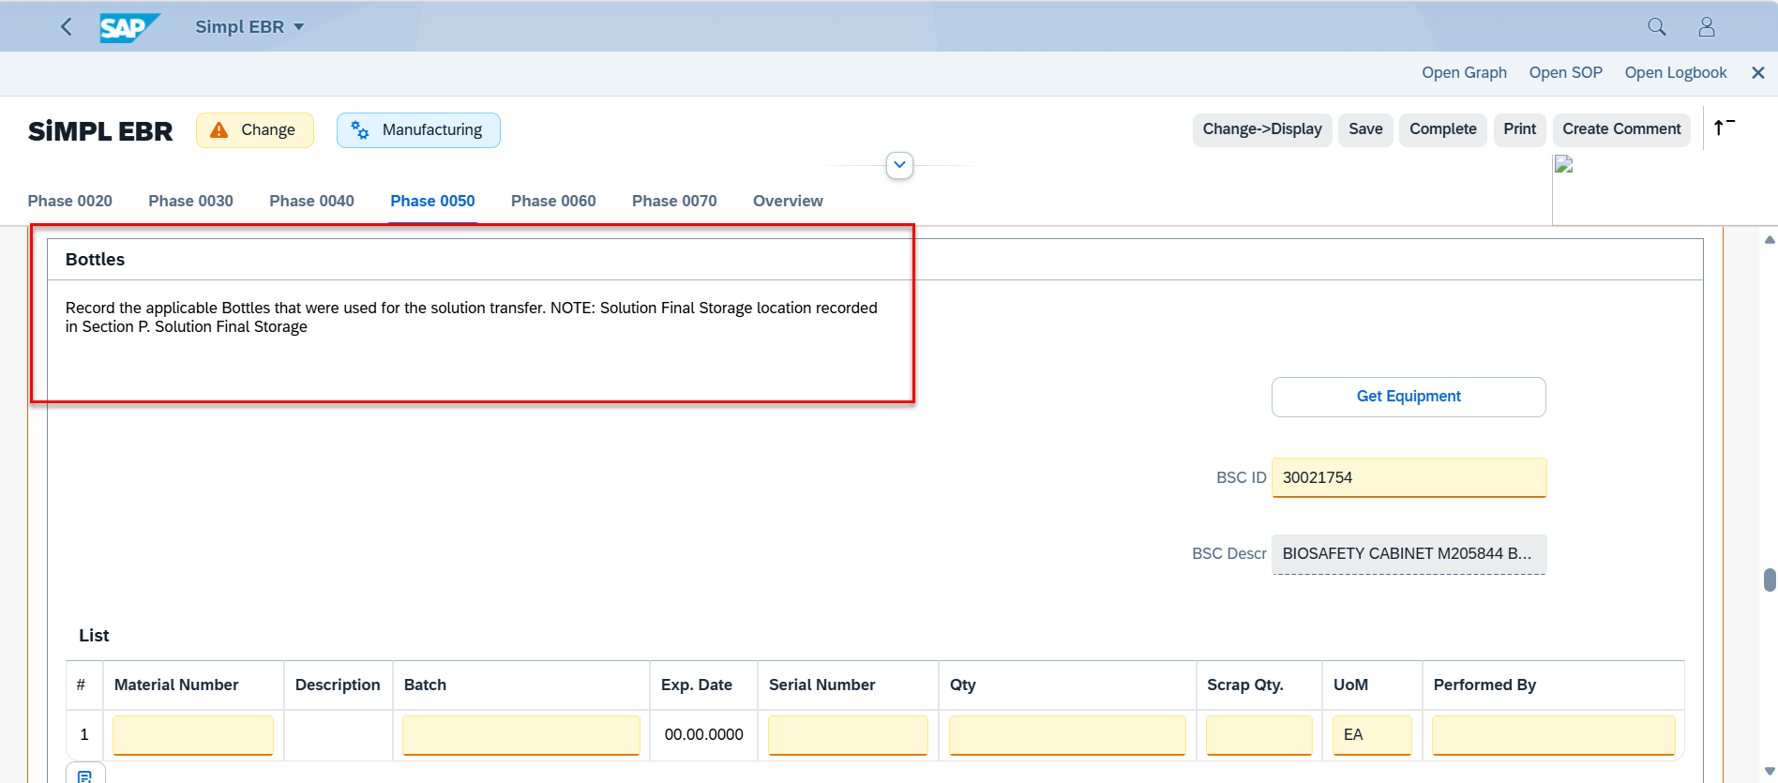

Step 4-6:
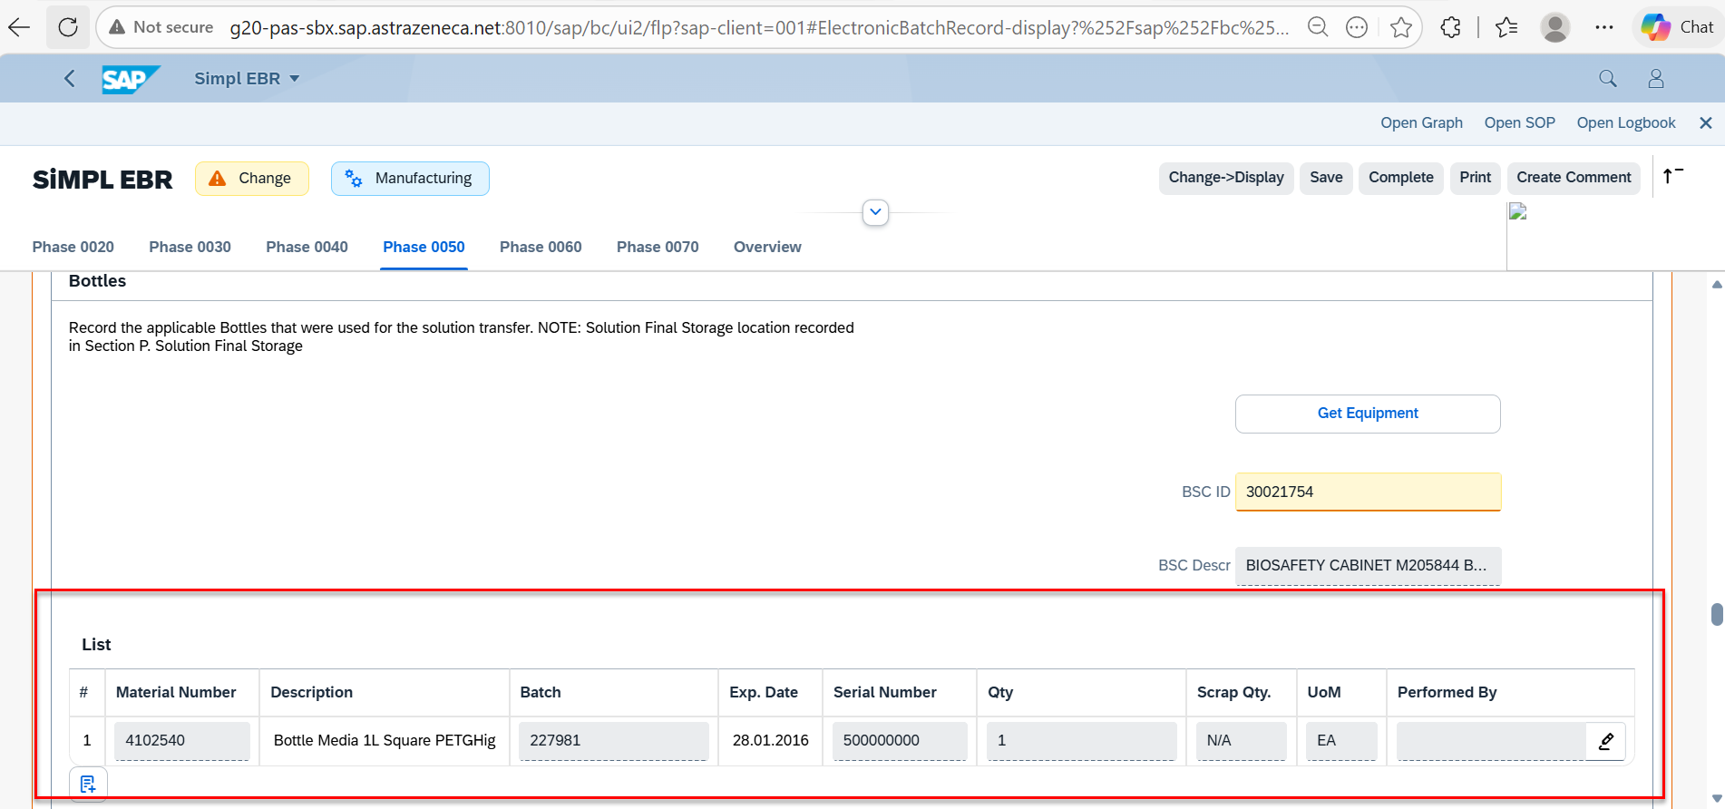

Variant 2: Unplanned Goods Issue
Step No. | Action / Description | Expected Result | Actual Result | Pass/ Fail  Test Issue Log #
1 | Create a Process Order that contains a SMPL: Component Goods Issue | Process Order created containing SMPL: Component Goods Issue | Process Order created containing SMPL: Component Goods Issue | Pass
2 | Open the EBR, and navigate to SMPL: Component Goods Issue | The EBR for the selected Process Order and Control Recipe opens successfully without any errors and the SMPL: Component Goods Issue is visible | The EBR for the selected Process Order and Control Recipe opens successfully without any errors and the SMPL: Component Goods Issueis visible | Pass
3 | The value entered in parameter IV_HEADER and parameter IV_INSTR in SiMPL MBR appears correctly in the XStep header | Header and instruction text are displayed as authored in SiMPL MBR | Header and instruction text are displayed correctly. | Pass
4 | “Yes” is selected from the dropdown input | Dropdown selection of “Yes” is accepted | Dropdown selection of “Yes” is accepted | Pass
5 | Operator inputs Material, Batch, Serial Number, Qty, Scrap Qty.,UoM. | Input details are accepted and correct. | Input details are accepted and correct. | Pass
6 | The operator verifies that Description and Exp. Date details are populated correctly. | Output details are populated correctly. | Output details are populated correctly. | Pass
7 | Enter a username in the “Performed By” field then enter the password in the pop-up window. | Signature is accepted | Signature is accepted | Pass
8 | Navigate to transaction CO54 to ensure process message is created successfully for goods issued on the current order | Process message exists with the correct details. | Process message exists with the correct details. | Pass

Step 1-3:
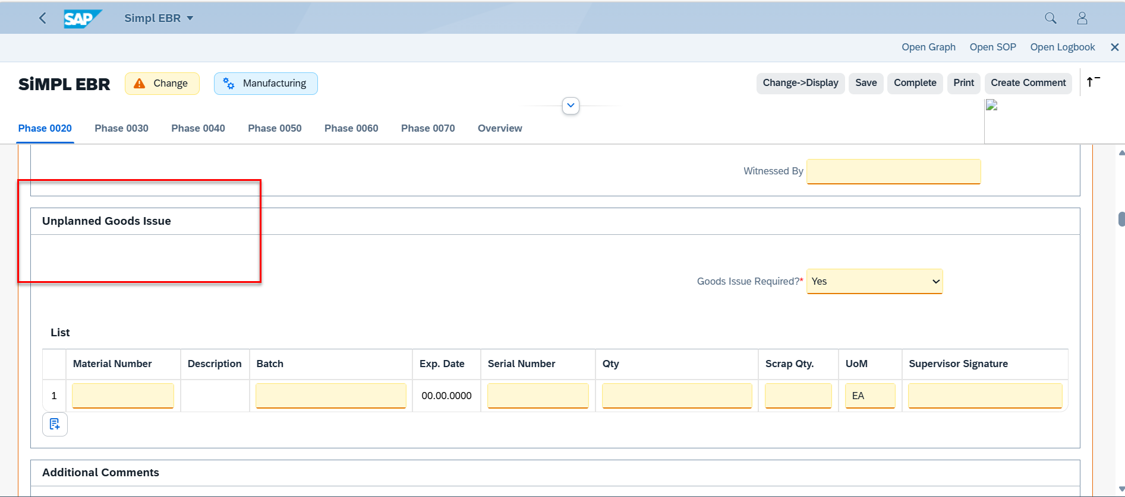

Step 4: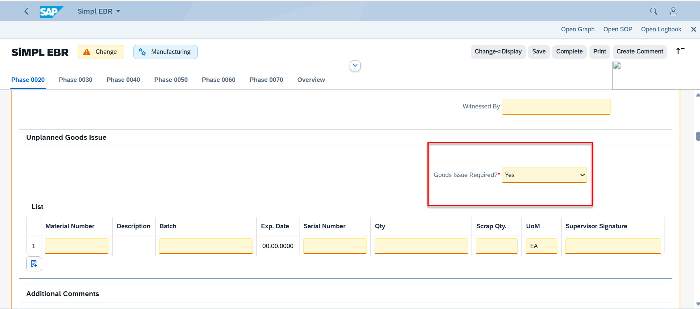

Step 5-7:
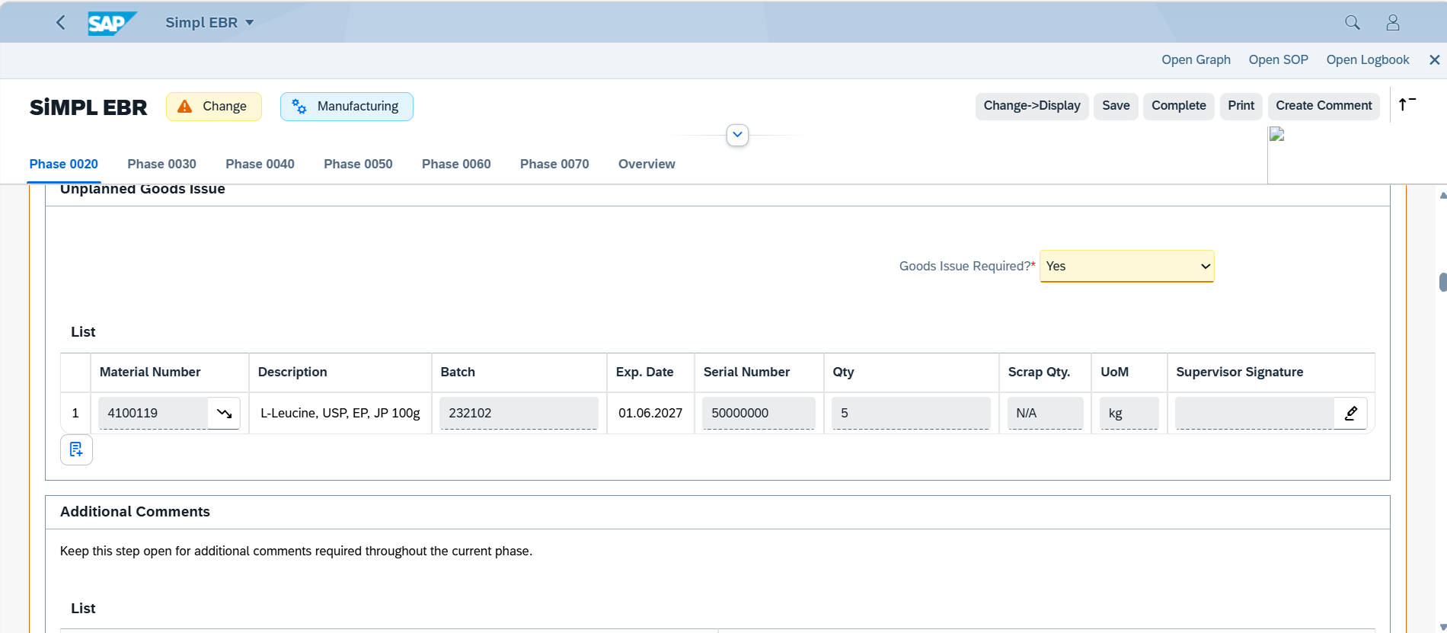

Step 8:

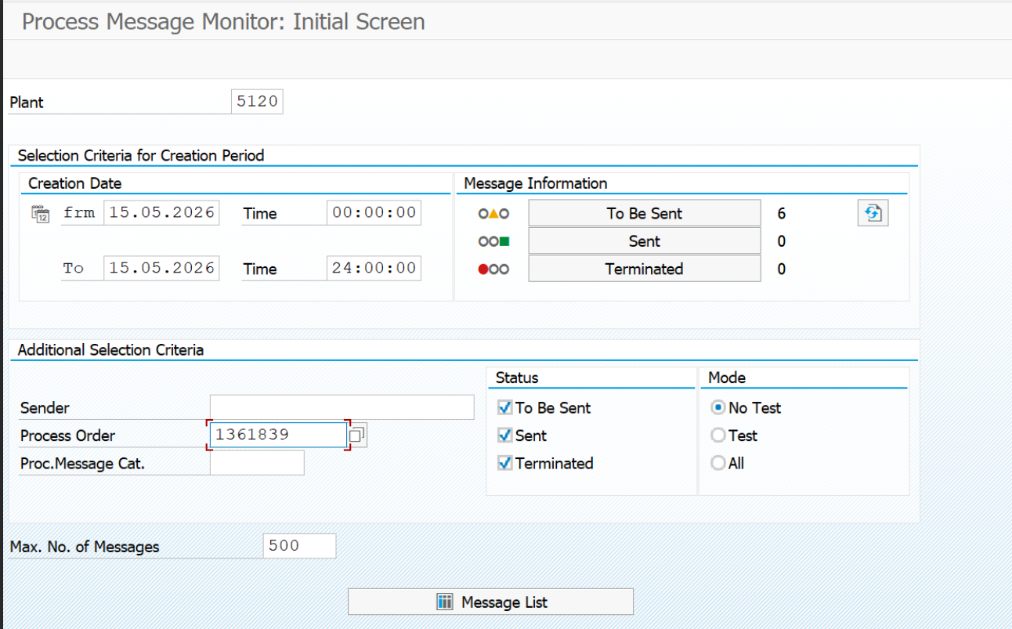
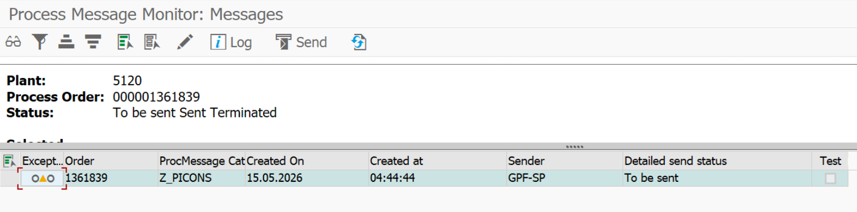

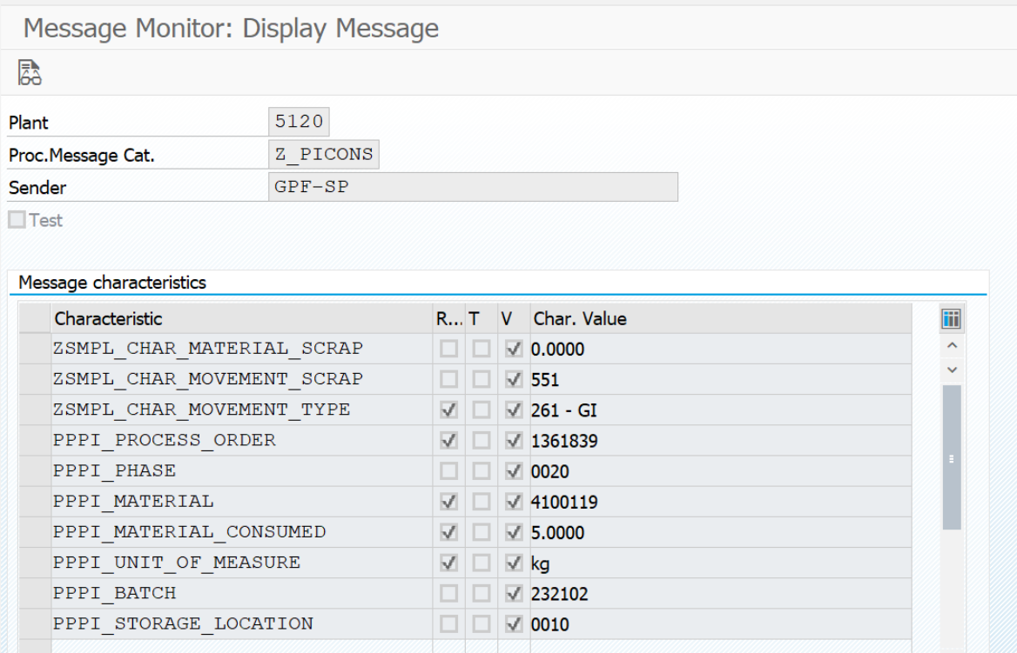

TEST SCRIPT SUMMARY RESULT
PASS/FAIL: | PASS | Comments:
Signature, Initials and Date Tester 1: | Kvhz810, 19/02/2026 | Printed Name  Tester 1: |  | Executed Steps
Signature, Initials and Date Tester 2 (if used): |  | Printed Name  Tester 2 (if used): |  | Executed Steps
Signature, Initials and Date Tester 3 (if used): |  | Printed Name  Tester 3 (if used): |  | Executed Steps
Signature and Initials Witness  (if used): |  | Printed Name Witness (if used):
Total Number of Test Issues Recorded for Test Script: |  | Total Number of Pages Attached:
Approver Signature and Date: |  | Approver Comments
Printed Name of Approver:
Second Approver Signature and Date (if applicable): |  | Approver Comment (if applicable)
Printed Name of Approver:
The above table shall be filled in by the tester(s) and approvers following execution of the test script

